**How to create BEx transport Request**

Bex Transport is used for transporting Bex objects using standard transport and Individual Package.

This Request is used for queries, workbook and web application objects. *If you have Bex transport then you* ***need not*** *collect Bex objects individually.*

Important thing is that *all the modification to Bex objects are collected into this request for all the users*. It is not user specific.

**Steps to create Bex Transport using Standard Transport.**

1. Go To RSA1 -> Transport Connection − кн. .
2. To create request click on Assign/Delete

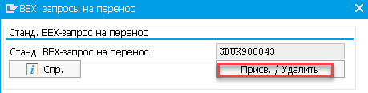

1. Create new request which your Bex standard transport request. A new request has to be created immediately after you release a BEx transport request. For this reason, either an administrator or project coordinator must create the requests centrally.

**Bex Transport using Individual package**

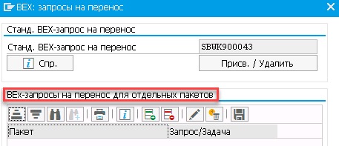- depend on your project requirement you should be decide to this *package option*.

There are possible reasons for this

1. Your project is large and *you want to divide Bex objects in different areas*.
2. *You want to send Bex objects to different production systems*.

**Note**

If a package has no specific request, the object is written to the standard BEx transport request.

# Transport Request For Bex

You will find a detailed description in [http://help.sap.com/saphelp_nw70ehp2/helpdata/en/38/5ee7377a98c17fe10000009b38f842/content.htm](http://help.sap.com/saphelp_nw70ehp2/helpdata/de/38/5ee7377a98c17fe10000009b38f842/content.htm)

and here - <http://help.sap.com/saphelp_nw70ehp2/helpdata/en/0b/5ee7377a98c17fe10000009b38f842/content.htm>

The steps are quite simple

1) Goto RSA1 and select Transport connection.

2) Select BEx within the Toolbar and create a BEX-Transport request.

3) *Select the BEx-Query and it dependend objects* - the dialog should list the dependend objects.

4) If your objects are not assigned to a development package, you should assign them via ***Package***.

5) Put your Objects via ***Collect*** into you new request.